The python code has a chi squared test comparing X and why where X is a 1941x27 array of a variety of numbers and y is a 1941x7 array of 1’s and 0’s.

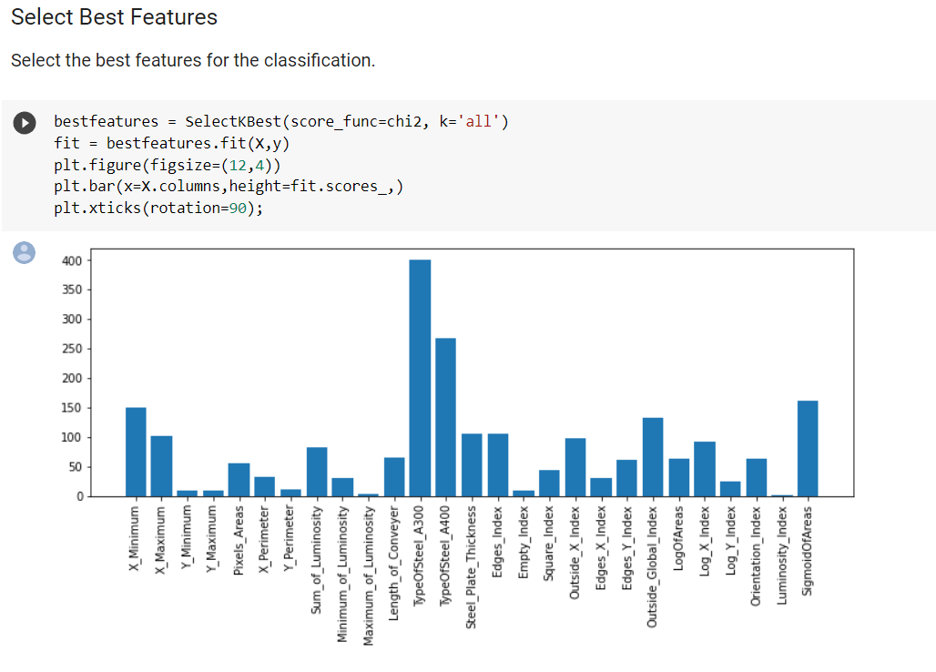

Mat lab will not let me perform a Chi squared test on the same 2 arrays and instead only us a vector of numbers for the comparing variable y.

X_s = table2array(data(:,features))

y_s = table2array(data(:,labels))

[fit, scores] = fscchi2(X_s, y_s(:,1));

Specs = features'

% Visualize feature scores

bar(scores)

set(gca, 'XTick', 1:length(features), 'XTickLabel', features)

xlim([0 length(features)+1])

xlabel('Features')

ylabel('Score')

box off

As you can see, the graphs are not the same because I am performing the chi squared test on only 1 of the seven columns of y whereas the python code is performing the chi squared test on all 7 columns of y.

**Question: Is there a way to run the chi squared test on all 7 columns of y or am I constrained to the vector with just 1 column?**

**Question: How do we use the MNIST database with fitcknn() in order to use a k-nearest neighbor classifier for text identification?**

**- currently working on this with Jon Loftin**

**Question: What function should we use for K-nearest neighbor regression ?**